Web Development Frontend

📘 Definition
# Source: AI Source: Provided by: [Data Path: Persons Table -> ID Column: 1, Name_En Column: Motasem Essam] -> From: [ChatGPT] on [5/5/2026]
Frontend web development is the part of web development that focuses on what users see and interact with in a website or web application.
It is also called the client-side.

🖥️ What frontend includes
# Source: AI Source: Provided by: [Data Path: Persons Table -> ID Column: 1, Name_En Column: Motasem Essam] -> From: [ChatGPT] on [5/5/2026]
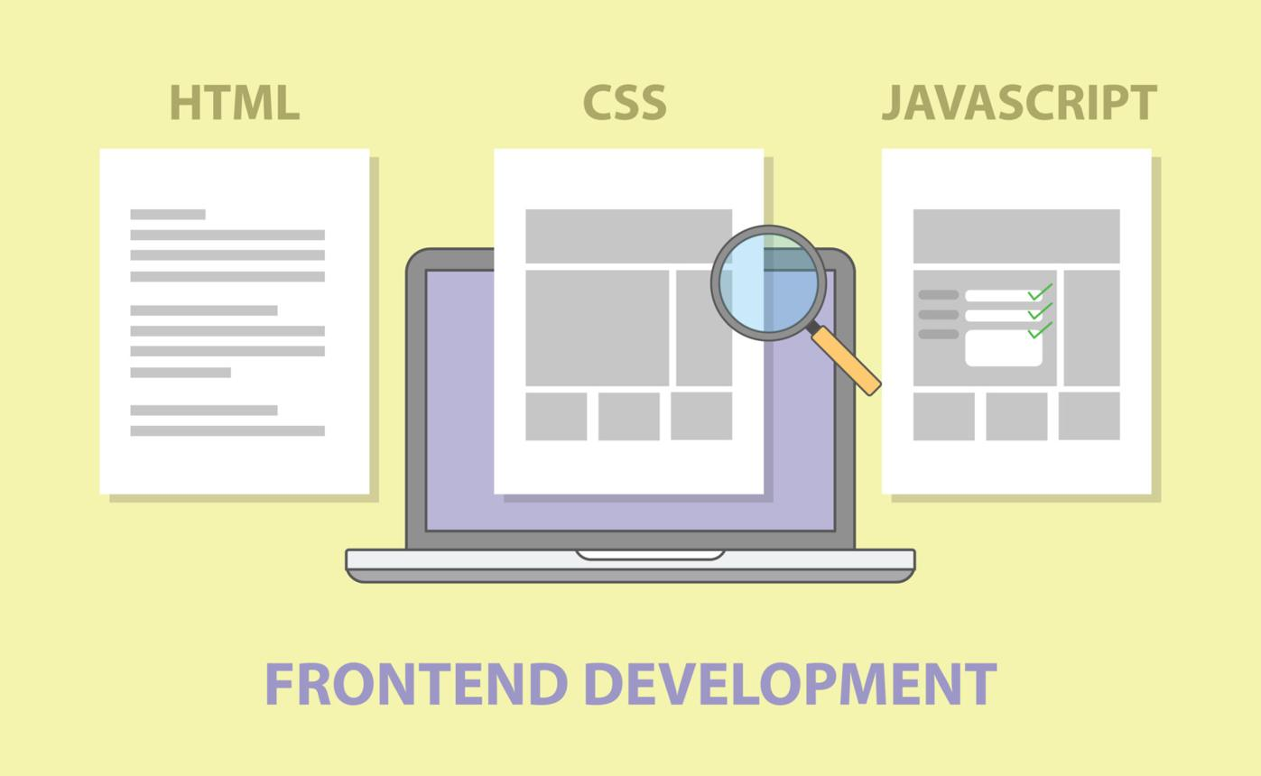
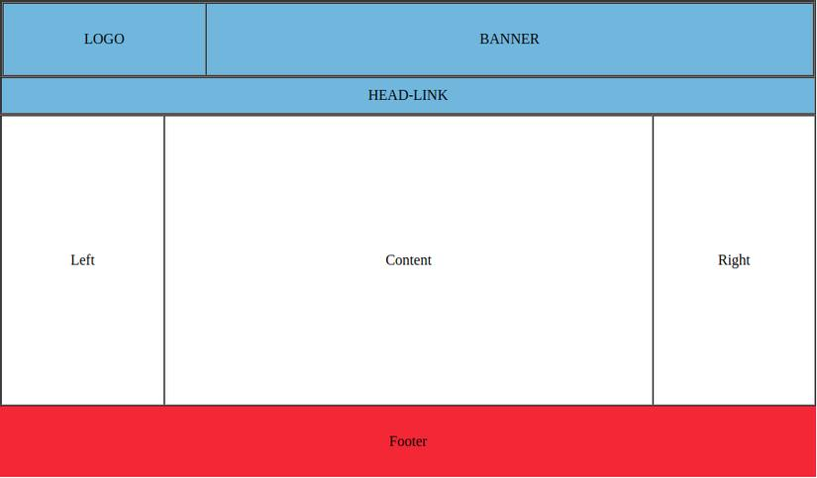
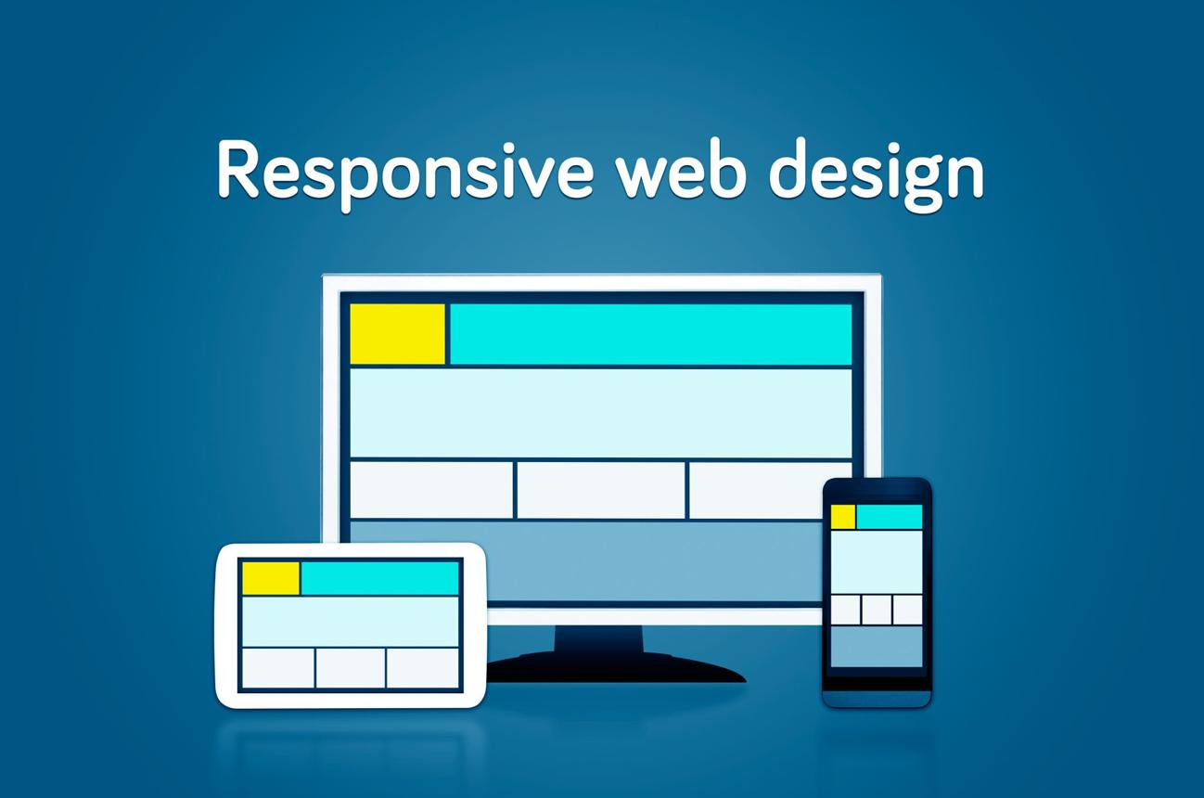
Frontend is built using:
- 🧱 HTML → structure (headings, paragraphs, layout)
- 🎨 CSS → design (colors, fonts, layout)
- ⚡ JavaScript → behavior (interactions, animations)

🧠 Simple example
# Source: AI Source: Provided by: [Data Path: Persons Table -> ID Column: 1, Name_En Column: Motasem Essam] -> From: [ChatGPT] on [5/5/2026]
Think of a website like a car:
- 🚗 Frontend = what you see (dashboard, steering wheel)
- ⚙️ Backend = engine (hidden logic)

🎮 What frontend developers do
# Source: AI Source: Provided by: [Data Path: Persons Table -> ID Column: 1, Name_En Column: Motasem Essam] -> From: [ChatGPT] on [5/5/2026]
- 🎨 Design user interface (UI)
- 🖱️ Add interactivity (buttons, forms, menus)
- 📱 Make responsive layouts (mobile & desktop)
- ⚡ Improve performance and user experience

🧩 Examples of frontend features
# Source: AI Source: Provided by: [Data Path: Persons Table -> ID Column: 1, Name_En Column: Motasem Essam] -> From: [ChatGPT] on [5/5/2026]
- Navigation menu
- Buttons and forms
- Images and videos
- Animations
- Responsive design

⚙️ Key features
# Source: AI Source: Provided by: [Data Path: Persons Table -> ID Column: 1, Name_En Column: Motasem Essam] -> From: [ChatGPT] on [5/5/2026]
- 👁️ Visible to users
- 🖱️ Interactive
- 📱 Works on different devices
- 🌐 Runs in the browser

🚀 In short:
# Source: AI Source: Provided by: [Data Path: Persons Table -> ID Column: 1, Name_En Column: Motasem Essam] -> From: [ChatGPT] on [5/5/2026]
Frontend web development = building the visual and interactive part of a website that users see and use in the browser.

